**CSC 496-80 Course Project – Installation and Deployment**

**Dimitra Deliopoulos, Desislava Atanasova**

**Github –** <https://github.com/dimitra216/CSC496-Team-Cloud-Project-DA>

**Abstract**

Install and deploy a multi-node computing service on CloudLab’s Openstack Cloud. Then select a computing service consisting of at least two service nodes and deploy the corresponding VMs inside CloudLab’s Openstack infrastructure.

Other goals include:

* Able to setup VM nodes that work together to provide a unified computing service to users.
* Able to move these VM nodes into the Cloud, setup proper network environment, and link them together.
* Able to setup at least 2-3 security groups, not using the default security groups on Openstack.

**First Approach Project Achieved/Goals**

The first webserver we attempted to use was the Tomcat server (version 9.0.31). After installing the webserver and the database server MySQL (server version 5.7.29) as well, it was up and running successfully on Ubuntu 18.04.4 VM.

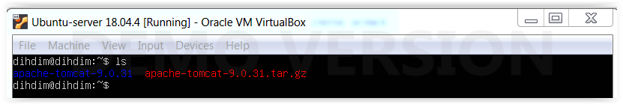

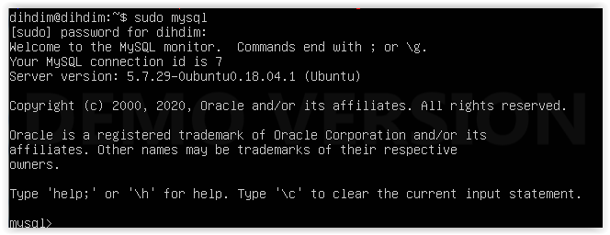

We have a ready to use Tomcat application server installed and successfully running when it is open in the browser.

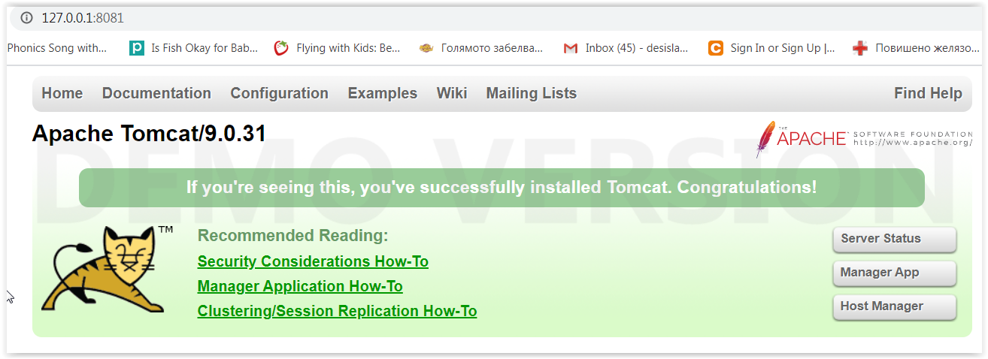

**First Approach - Complications**

The problem we encountered was to create an image in OpenStack for one of our machines.

State “Queued” lasts forever.



**First Approach - Conclusion**

Even though we were successfully able to install the webserver and the SQL database on our local computers, OpenStack ended up not being able to upload an image successfully. It gave an extremely long Queued time that eventually prompted an error explaining an image cannot be retrieved. Multiple attempts were made to add a different type of image with different settings, but none were successful through OpenStack.

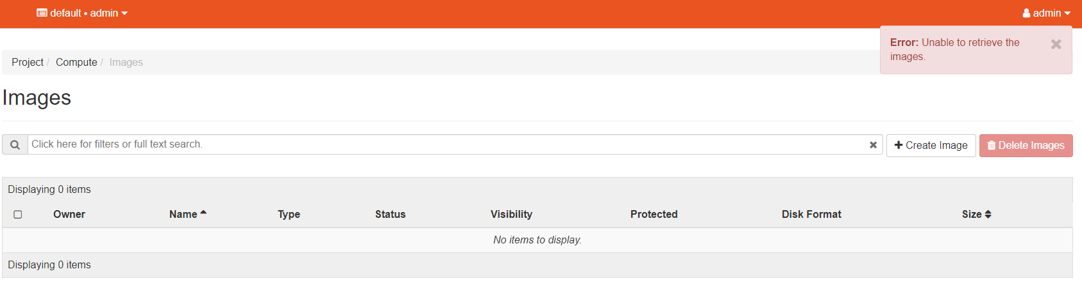

**Second Approach - Project Achieved/Goals**

On a different week, OpenStack seemed to work and was able to upload images/instances. The problem from the first approach seemed to be the OpenStack/CloudLab service itself. After some time working with the second approach, the achieved goal was an accessible SQL form that can be filled out and submitted. This data was held in the backend SQL server that was already implemented.

IP address: <http://128.105.146.179/> (May change due to floating IP issues involving CloudLab)

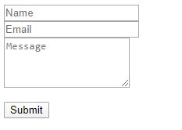

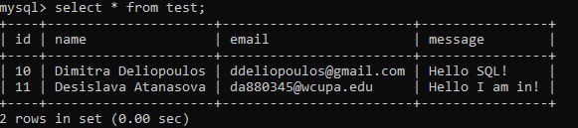

**CloudLab - Profile**

The profile provides a highly configurable OpenStack instance with a controller and one or more compute nodes (potentially at multiple Cloudlab sites) (and optionally a network manager node, in a split configuration). This profile runs x86, arm64, and POWER8 (Queens and up) nodes. It sets up OpenStack Stein (Ubuntu 18.04, python3), Rocky, Queens (Ubuntu 18.04, python2), Pike, Ocata, Newton, or Mitaka (Ubuntu 16.04, python2) (Liberty on 15.10, Kilo on 15.04, and Juno on 14.10, python2, deprecated) according to your choice, and configures all OpenStack services, pulls in some VM disk images, and creates basic networks accessible via floating IPs.

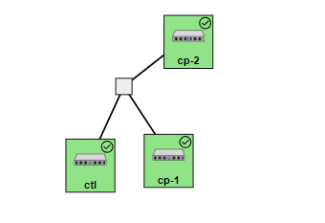

**OpenStack - Network Configuration**

Created allocation pools in the subnet ext-net that include:

[128.105.146.176], [128.105.146.177], [128.105.146.178], [128.105.146.179]

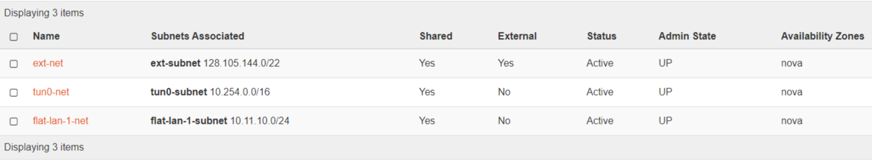

The network includes two routers, one router connects to the *tun0-net* network and the other connects to the *flat-lan-1-net* network, and both routers are connected to the *ext-net* network. The instances mysql_server and the apache-webserver have interfaces on both *tun0-net* and *flat-lan-1-net* networks.

**Topology of network connections:**

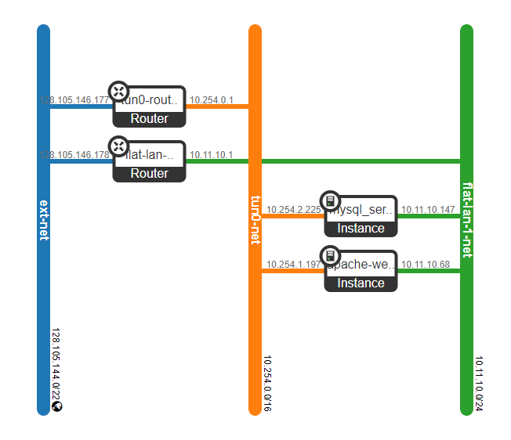

**OpenStack – Images**

Created an image using, “bionic-server-cloudimg-amd64”, named “ubuntu-server”, which has a disk format of QCOW2 and is just a standard ubuntu-server 18.04 used specifically for cloud purposes. Launched both instances using that image, then created a few snapshots of the same image after installing the essential components to the servers.

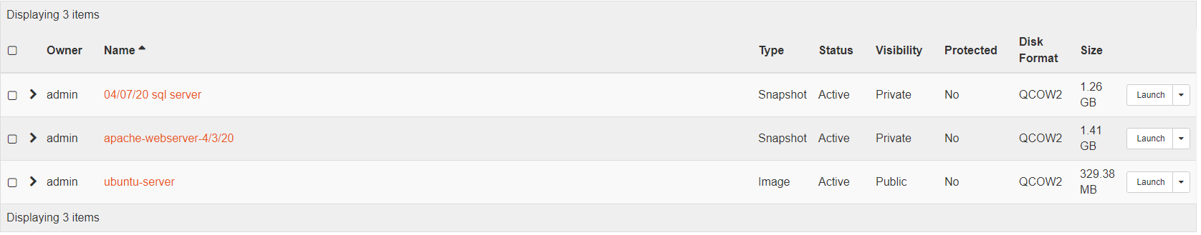

**OpenStack – Instances**

Created the instances and went through the OpenStack options to create its infrastructure which in our case specifically include: Details, source, flavor, networks, security groups, and key pair. The details were providing a name for the instance and a description (mysql_server, apache-webserever). The source includes the image using (ubuntu-server). The flavor for the apache-webserver was m1.medium and m1.small for the mysql_server. These allocate specific resources to the server. The networks connected to the instances include the *flat-lan-1-net* and *tun0-net.* A key pair was added to be able to connect to the servers remotely from the local computer.

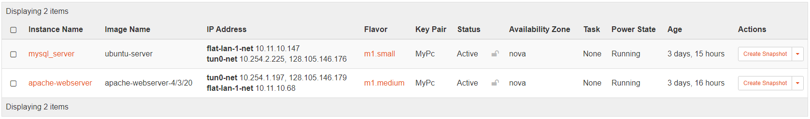

As for the security groups, I kept most the default rules, but added the TCP port 80 to be able to access the HTTP pages and be able to view the webserver created.

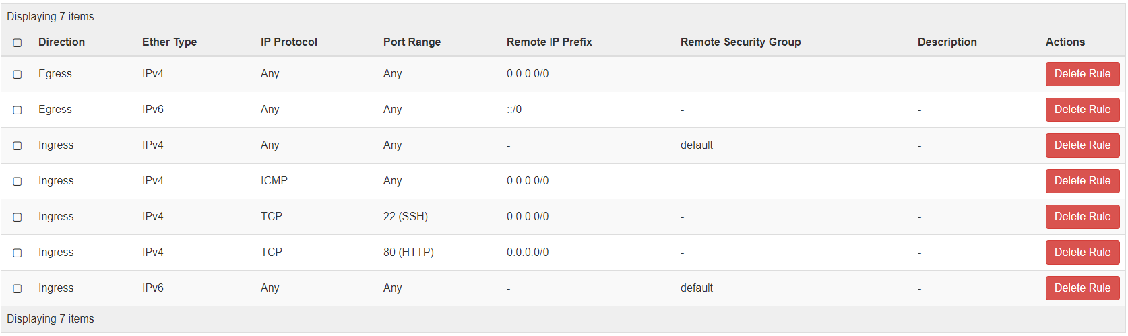

**OpenStack – Overview**

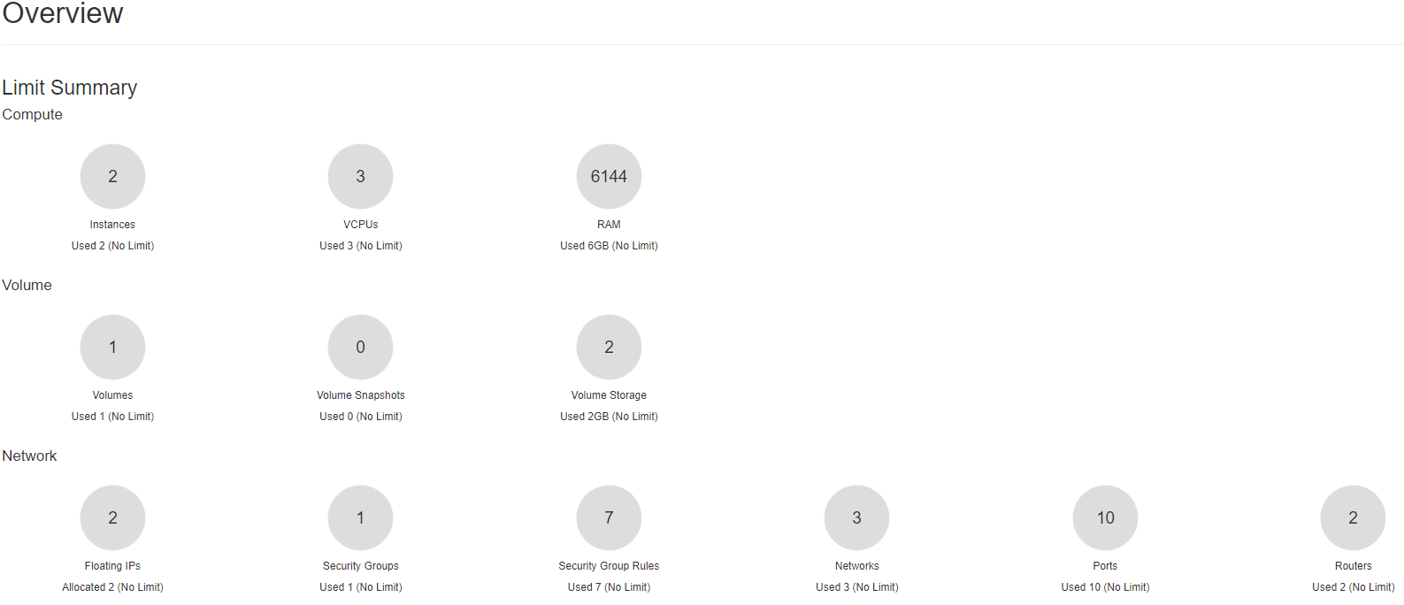

**Second Approach Problems**

The goal to add a better UI for the SQL database and login service did not work out as planned because the free PHP scripts used did not comply with the webserver used. Attempts were made by changing the backend webserver settings to read the PHP scripts uploaded but ended up doing more harm to the original project. A snapshot of the original project was preserved and eventually became the final project.

Also, after about three weeks of having the CloudLab/OpenStack project up, access to the OpenStack dashboard came with complications. Every login would show an error, stating it was unable to retrieve usage information. The floating IP’s were still up and running though and access to the project was still available. We were just unable to see our images/instances in the dashboard.

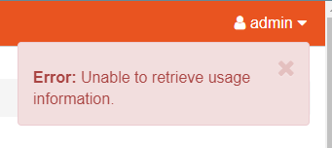

**Conclusion**

In conclusion, the project was successfully implemented and works well. Installation of all the necessary components on the servers were finished and adjusted to fit the project idea. There were plenty of complications and different approaches along the way, but we succeeded in our goal of implementing the webserver and SQL server and having them connect to the given network together.

**References**

<https://docs.openstack.org/train/>

https://dev.mysql.com/doc/refman/5.6/en/drop-user.html

https://dev.to/alwaysup/create-a-web-server-and-save-form-data-into-mysql-database-using-php-beginners-guide-fah

https://www.digitalocean.com/community/tutorials/how-to-install-mysql-on-ubuntu-18-04

https://support.rackspace.com/how-to/mysql-connect-to-your-database-remotely/

<https://www.configserverfirewall.com/ubuntu-linux/enable-mysql-remote-access-ubuntu/>

https://code-boxx.com/php-mysql-search/

<https://tomcat.apache.org/download-90.cgi>